**USE CASE DIAGRAM**

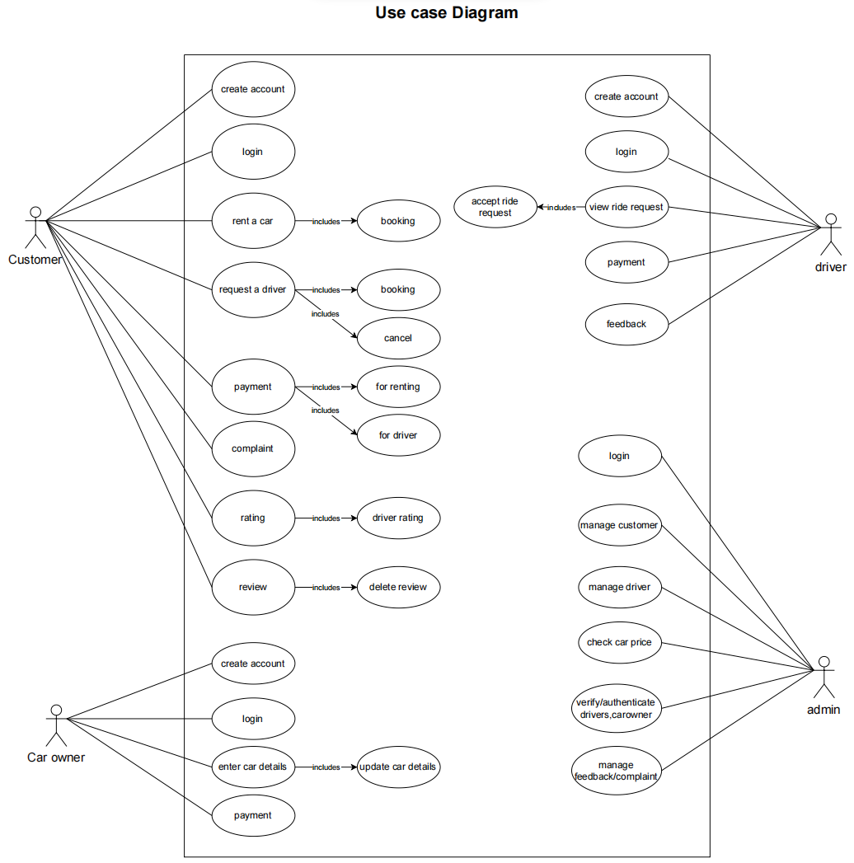

**SEQUENCE DIAGRAM**

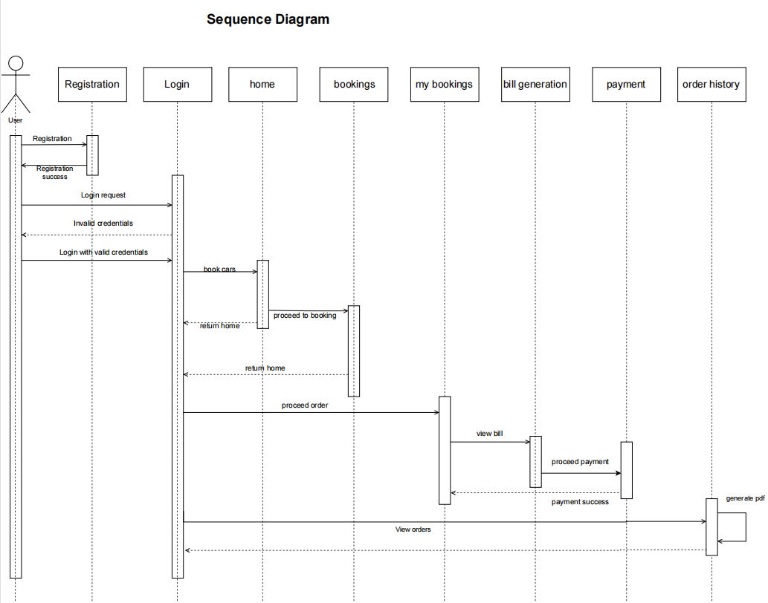

**STATE DIAGRAM**

### 

**ACTIVITY DIAGRAM**

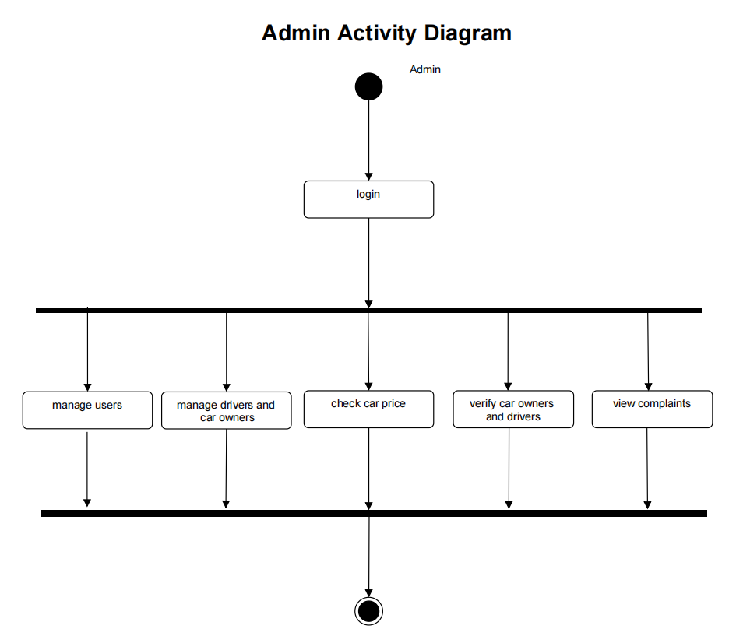

### 

### CLASS DIAGRAM

### 

**OBJECT DIAGRAM**

### 

### COMPONENT DIAGRAM

